**MEMFULL**

**A project Report**

**Submitted to**



**STATE BOARD OF TECHNICAL EDUCATION AND TRAINING,**

**ANDHRA PRADESH**

***In the partial fulfillment of the requirements for the award of the degree of***

**DIPLOMA**

**IN**

**COMPUTER ENGINEERING**

**By**

**P. JAYANTH (22018-CM-052)**

**B. SHARATH (22018-CM-030)**

**P. BHASKAR (22018-CM-053)**

**P. NARASIMHULU (22018-CM-066)**

**R. JASHMITHA (22018-CM-016)**

**Under the esteemed guidance of**

**G. HARI SANKAR, M. TECH,**

**Lecturer**



**SRI VENKATESWARA GOVERNMENT POLYTECHNIC**

**Affiliated to State Board of Technical Education and Training AP, Opp. T.T.D Administration Building, K. T. Road, Tirupati-517501, Andhra Pradesh.**

**DEPARTMENT OF COMPUTER ENGINEERING**



**BONAFIDE CERTIFICATE**

This is to certify that the project entitled “**MEMFULL”** is a bonafide work done **P. JAYANTH (22018-CM-052), B. SHARATH (22018-CM-030), P. BHASKAR (22018-CM-053), P. NARASIMHULU (22018-CM-066), R. JASHMITHA (22018-CM-016)** *for the partial fulfillment of the requirements for the award of* Diploma in Computer Engineering, State Board of Technical Education and Training, Andhra Pradesh during 2024-2025.

**Project Guide**      **Head of the Department**

G. HARI SANKAR , M.Tech , G. BOSUBABU , M.Tech.,

LECTURER HCMES

Department of CME SVGP, Tirupati – 517501

SVGP, Tirupati - 517501

**Date: ____________**

**Internal Examiner Head of The Department External Examiner**

**DECLARATION**

We hereby declare that the project report entitled “**MEMFULL**” done by us under the guidance of **G. HARI SANKAR**, M.Tech., Lecturer in Computer Engineering and is submitted in partial fulfillment of requirements for the award of Diploma in Computer Engineering**.** This report is the result of our effort and it has not been submitted to any other University or Institution for the award of any degree or diploma other than specified above.

Date:

Place:

**P. JAYANTH (22018-CM-052)**

**B. SHARATH (22018-CM-030)**

**P. BHASKAR (22018-CM-053)**

**P. NARASIMHULU (22018-CM-066)**

**R. JASHMITHA (22018-CM-016)**

**ACKNOWLEDGEMENT**

We are thankful to our guide **G. HARI SANKAR, M.Tech, Lecturer in Computer Engineering** for his valuable guidance and encouragement. Sir, helping attitude and suggestions have helped in the successful completion of the project.

We would like to express our gratefulness and sincere thanks to

**G. BOSU BABU, M.Tech., Head of Computer Engineering Section,** for his kind help and encouragement during the course of study and in the successful completion of the project work.

We have a great pleasure in expressing our hearty thanks to our beloved **Principal Dr. Y. DWARAKANATHA REDDY M.sc, Ph.D** for providing the facilities for the successful completion of the project work.

Successful completion of the project cannot be done without proper support and encouragement. We sincerely thank the **SBTET** for providing all the necessary facilities during course of study.

**P. JAYANTH (22018-CM-052)**

**B. SHARATH (22018-CM-030)**

**P. BHASKAR (22018-CM-053)**

**P. NARASIMHULU (22018-CM-066)**

**R. JASHMITHA (22018-CM-016)**

**ABSTRACT**

Memfull is cutting-edge project which will be a great resource to the Travelling Enthusiasts. Here we strive to guide a way to gain a lot of treasurable movements to the users. Memfull website we provide the must visit places near a search location. We also provide the History of the location, Specialty of the location, with the geolocation link in the google maps, and with the shared user experiences.

The platform facilitates the History of the searched locations, Specialty of the searched location, the geolocation link in the google maps and with the shared user experiences. We also facilitate the logged in users to add the locations to the website so, it will be helpful for the other Travel Enthusiasts to find the remote locations.

**INDEX**

|  |  |  |
| --- | --- | --- |
| **Chapter No.** | **Description** | **Page No.** |
| 1 | Introduction | 1 |
| 2 | System Analysis  2.1 Existing System  2.2 Proposed System | 2-3 |
| 3 | Project Description | 4-6 |
| 4 | Computational Environment  4.1 Software requirements  4.2 Hardware requirements  4.3 Operating environment  4.4 External requirements  4.5 Non-functional requirements  4.6 Software features | 7-18 |
| 5 | Feasibility Study  5.1 Technical Feasibility  5.2 Operational Feasibility  5.3 Economical Feasibility | 19-20 |
| 6 | SYSTEM DESIGN  6.1 Architecture  6.2 UML Diagram | 21-26 |
| 7 | SYSTEM IMPLEMENTATION  7.1 Modules 7.2 User: | 27-29 |
| 8 | Sample source code | 30-45 |
| 9 | User interface designs  9.1 Home page  9.2 Destinations page  9.3 Details page  9.4 Contribution page  9.5 Login page  9.6 Signup page | 46-50 |
| 10 | Testing  10.1 Testcases | 51-56 |
| 11 | Conclusion | 57 |
| 12 | Future Enhancement | 58-59 |
| 13 | References | 60 |

**1. INTRODUCTION**

Welcome to Memfull a stand out as an innovative project born from the need to simplify travel planning for enthusiasts. The idea sprang from the realization of how inconvenient it was for myself and fellow travellers to pinpoint the best locations to visit. This platform not only streamlines the process of discovering must-see spots but also enhances the overall travel experience by providing tailored recommendations and detailed insights, making spontaneous adventures or meticulously planned trips effortless and enjoyable.

Throughout this introduction, we will explore the key components of Memfull, including its purpose, target audience, features, and technical implementation. Additionally, we will delve into the benefits of using Memfull for travel enthusiasts, and the also highlights how simple it is to search the locations in the Memfull.

You will have a comprehensive understanding of how Memfull works, its value proposition, and how it aims to transform the traveller’s life in searching the places. Whether you are a prospective user or simply interested in innovative solutions in the tourism sector, we invite you to explore Memfull and discover the possibilities it offers for travel enthusiasts.

**2. SYSTEM ANALYSIS**

**2.1 Existing System:**

In the realm travelling is a beautiful thing but searching for the place to visit and find the route to it will be difficult for the travel enthusiasts and the travel enthusiasts have search whole internet to find route to the destination. Lacking of the reliable platform for the traveler’s to find the where and how to visit the destination.

**2.2 Proposed System:**

Memfull is the perfect solution to these issues. By providing a comprehensive platform that curates must-visit spots near the user's location, Memfull simplifies the process of discovering new places. It also offers detailed directions and user-generated content to ensure that travelers have all the information they need at their fingertips. Memfull transforms the travel planning experience, making it seamless, enjoyable, and tailored to each user's preferences. Say goodbye to the hassle and hello to unforgettable adventures with Memfull.

Moreover, Memfull empowers its users by allowing them to contribute to the ever-growing database of loc

ations, creating a vibrant community of explorers sharing their experiences. Whether you're planning a spontaneous weekend getaway or a meticulously planned trip, Memfull provides the insights and tools needed to make every journey memorable. Embrace the ease and excitement of travel with Memfull, where each adventure is just a click away

**ADVANTAGES:**

**1. Efficiency:** The proposed system streamlines service connections, reducing search time and enhancing overall efficiency for both service seekers and providers through intuitive design and advanced functionalities.

**2. Reliability:** By curating a community of skilled professionals and implementing secure data handling, the platform ensures reliable and trustworthy service interactions, fostering a sense of confidence among users.

**3. User-Friendly Interface:** The intuitive design of the platform makes it easy for users to navigate and access services, contributing to a positive and seamless user experience, even for those with limited technical expertise.

**4. Scalability:** The system's architecture is designed to accommodate future growth, ensuring scalability as user demands increase and the platform evolves to meet emerging requirements in the dynamic digital landscape.

**5. Collaborative Community:** The platform encourages collaboration between service seekers and providers, creating a community-driven space where users can connect, share expertise, and contribute to a supportive and interactive environment.

**6. Ever growing database:** The platform enables the user to contribute to the database so there will always new locations every day.

**3. PROJECT DESCRIPTION**

Memfull is a revolutionary travel platform designed to enhance the journey of explorers by providing an intuitive way to discover must-visit locations near their searched areas. By harnessing advanced geolocation technology, Memfull curates personalized recommendations of cultural landmarks, natural wonders, and hidden gems, ensuring travellers can effortlessly find the best spots to visit.

The platform also empowers users by allowing them to contribute to the community. Travelers can add new places they discover, complete with descriptions, photos, and reviews, enriching the database for future adventurers. This user-generated content fosters a vibrant, ever-growing resource that adapts to the needs and interests of its users.

With Memfull, planning trips becomes a breeze, transforming the way people experience and explore the world around them.

**Key Features:**

**Home Page:**

Memfull is inspired from this situation “when we travel to the new places we will capture many movements and in our mobile phones so the memory our mobile will be filled so, from memory full we created the title ‘Memfull’ “

Navigation Menu: Explore seamlessly through our website with our intuitive navigation menu, providing easy access to various sections.

Search Bar: Helps user to quickly search the places.

Feedback: Which enables the user to give suggestions to the us to improve in the future.

Contact us: Helps user to connect to us through the social media pages.

**Destinations Page:**

Popular destinations: The must visit places in India which are our recommendations

Seach: Enables user to search using the place, nearby place and the category.

Speciality: Describe a little about the speciality of the place.

High quality images: Previews the place beauty.

**Details page:**

History of the location: Provides the detailed history of the location.

Beauty of the location: Provides the detailed speciality of the location.

Route from a famous place: Provides the detailed route to reach the location from the famous place in India.

Google map location: Provides the user link to the google maps with the destinations marked in it so, it easy to the user to travel to the destination.

Comment box: Facilitates the user to share the experience with the traveller’s community and read the comments of the other travellers in the community.

User images: Facilitates the traveller to share his experience in the form of images to travellers in the community and also see the experiences of the other travellers.

**Contribution page:**

Contribution: We facilitate the user to add the places to the database so, other travellers also experience the places. This can be done only if the user is logged in.

**Technology Stack:**

**Frontend**: HTML5, CSS3, JavaScript - Ensures a seamless and attractive website.

**Backend:** Php, - Provides simple and scalable infrastructure to support our range of features and functionalities.

**Database:** MySQL - Offers reliability, performance, and data integrity for managing our extensive content database.

**Conclusion:**

Memfull is a revolutionary project to make the travellers life easy by simplifying searching the places near a location by creating a platform for sharing the places and experiences of the travel enthusiasts.

**4. Computational Environment**

**User Integration:**

Memfull aims to provide a cohesive user experience by integrating various features across different pages so, that user can have the great experience. And also, by providing the feature to edit the location details and features activities to do in the specified place like boating, try the new varieties of the food.

**Scalability:**

The project scope includes designing Memfull with scalability in mind to accommodate potential growth in user traffic and property listings. This involves utilizing scalable infrastructure, such as cloud services, and implementing efficient coding practices to ensure the platform can handle increased loads without compromising performance. Additionally, features like load balancing and caching mechanisms will be implemented to optimize platform performance.

**Communication:**

The project scope for Memfull involves implementing effective communication features to enhance user engagement and facilitate seamless interaction across the platform. Added features such as notifications and updates will be implemented to make the user to know about what are other activities to experience in their location.

**User Authentication and Access Control:**

Security is paramount for Memfull. The project scope encompasses implementing robust user authentication mechanisms to verify user identities and prevent unauthorized access to sensitive information. Access control features will be integrated to regulate user permissions, ensuring that only authenticated users can contribute or access certain functionalities. Multi-factor authentication options may also be considered to further enhance security measures.

**Security and Data Privacy:**

Memfull prioritizes the security and privacy of user data. The project scope involves implementing encryption protocols to safeguard data transmission and storage. Additionally, measures will be implemented to comply with data privacy regulations, ensuring that user information is handled responsibly and transparently. Regular security audits and updates will also be conducted to mitigate potential vulnerabilities and ensure ongoing data protection.

By adhering to this comprehensive project scope, Memfull will deliver a secure, user-friendly, and scalable platform that fosters seamless communication, integration, and engagement for its users, while prioritizing security and data privacy.

**3.1 SOFTWARE REQUIREMENTS**

* XAMPP
* HTML
* APACHE Web Server
* CSS
* JS
* PHP
* MYSQL
* VS CODE

**3.2 HARDWARE REQUIREMENTS**

Hardware requirements refer to the specific components and specifications that a computer system or device needs to meet in order to run a particular software application or perform a specific task effectively. These requirements are outlined by software developers or manufacturers to ensure optimal performance and compatibility.

* Personal computer
* RAM-4GB
* Hard Disk-512GB
* Mouse/Keyboard

**3.3 OPERATING ENVIRONMENT**

The operating environment for a Memfulls typically includes:

**Operating** **System**:

The application may run on various operating systems such as Windows, Linux, or mac OS depending on the software requirements.

**Networking**:

A network infrastructure is essential for communication between different components of the system.

**Security** **Measures**:

Robust security measures are crucial to protect sensitive patient data, including access control, encryption, and regular security updates.

**User Interfaces**:

User-friendly interfaces for both administrators and end-users should be provided to facilitate easy data entry, retrieval, and management.

**Integration**:

Integration with other tourism organizations such as AP Tourism and IRCTC Tourism may be necessary for seamless workflow and data exchange.

These components collectively create a robust operating environment for a Computer Tech Hub website ensuring efficient and secure management.

**3.4 EXTERNAL REQUIREMENTS**

External requirements for a Memfull project may include:

**Security**:

Implement robust security measures to protect the data of the places and the user login data. This includes access control, encryption, and regular security audits

**Scalability**:

Design the system to handle varying levels of demand and scalability, considering factors such as the easily navigating to other pages through menu bar.

**User** **Accessibility**:

Ensure the system is user-friendly and accessible to staff with varying levels of technical expertise. Consider incorporating features such as role-based access control and multilingual support.

**3.5 NON-FUNCTIONAL REQUIREMENTS**

**Performance requirements:**

The system should be designed optimal performance, ensuring fact response times and minimal latency. This includes efficient code implementation, database query optimization and server resource management.

**Compatibility Requirements:**

The system should be compatible with multiple web browsers operating systems, and devices to ensure broad accessibility. It should adhere to web standards and best practices to ensure consistent behavior across different platforms.

**Maintainability:**

The system should be developed with clean and modular code, following best coding practices.

**Security:**

The system should employ more secure measures to protect user data, prevent unauthorized access and ensure the integrity of the process. This includes secure communications, encryption of sensitive data, strong password policies, protection against common web vulnerabilities.

**Reliability:**

The system should be reliable and available during the entire period. It should be designed to handle a large number of concurrent users without performance degradation or system failures.

**Scalability:**

The system should be scalable to accommodate an increasing number of users and owners. It should be able to handle a growth database and concurrent user request without sacrificing performance.

**3.6 SOFTWARE FEATURES**

**HTML:**

Hyper Text Markup Language is a computer language devised which allows website creation. It is the HTML code that provides an overall framework of how the site will work. These websites can be viewed by anyone else connected to the internet.

**Features of HTML:**

• It is the language which can be easily understood and can be modified.

• Effective presentations can be made with the HTML with the help of its formatting tags.

• It provides more flexible way to design web pages along with the text.

• Links can be also added to the web pages. It helps the readers to browse the information of their interest.

• You can display HTML documents on any platforms such as Windows, Linux etc.

• Graphics, videos and sounds can also be added to the web pages which give an extra attractive look to the web pages.

**CSS:**

Cascading Style Sheets is a style sheet language used to describe presentation and layout of HTML tags. It controls the presentation aspect of the site and allows site to have its own unique look. It does this by maintaining style sheets, which sit top on other styles rules and are triggered based on other inputs, such as device screen size and resolution.

**Features of CSS:**

**Easily maintainable:**

If you are intended to make any global change, simply change the styling and you can see all other elements in all other webpages getting automatically updated.

**CSS is time-saving:**

You can write the script once and reuse the same sheets as much time as you want.

**Superior styles to native front end:**

CSS have completely a wider array of attributes and list if compared to HTML. Therefore, HTML page can have a brighter look and feel if compared to the normal HTML attributes.

**Ease with Search Engines**:

CSS is considered as a very convenient and an easy wat to read styling sheet. This means, that the search engines don’t have to put in a lot of efforts in trying to read the text.

**Efficient cache storing:**

CSS can be used to store the web applications locally with the help of offline cache mechanisms which can be used to view the offline websites.

**JavaScript:**

JavaScript is a versatile programming language that has evolved over the years, providing developers with a wide range of features and capabilities.

**Features of JavaScript:**

**Event-Driven Programming:**

JavaScript is commonly used for building interactive web applications, and it has extensive support for event-driven programming. You can attach event handlers to HTML elements and respond to various user actions such as mouse clicks, key presses, and form submissions.

**Modules:**

Modern JavaScript (ES6 and later) supports modules, which provide a way to organize and reuse code. Modules allow you to define private and public members, making your code more modular, maintainable, and shareable.

**DOM Manipulation:**

JavaScript can manipulate the Document Object Model (DOM) of a web page, allowing you to dynamically modify its content, structure, and styles. This enables you to create interactive and responsive user interfaces.

**Error Handling:**

JavaScript provides try/catch blocks for handling exceptions and errors. You can catch and handle exceptions gracefully, preventing your program from crashing and allowing for proper error recovery.

**PHP:**

PHP (Hypertext Preprocessor) is a popular scripting language primarily used for web development.

**Features of php:**

**Cross-platform compatibility:**

PHP is a cross-platform language, which means it can run on various operating systems such as windows, macOS, Linux, and Unix. It is compatible with all major web servers like Apache, Nginx, and Microsoft IIS.

**Database support:**

PHP has extensive support for databases. It offers built-in extensions to connect to various databases such as MySQL, PostgreSQL, Oracle, SQLite, and more. This allows developers to easily interact with databases and perform tasks like data retrieval, insertion, deletion, and modification.

**Scalability and Performance:**

PHP can handle high traffic websites and scalable applications. With various caching mechanisms, opcode caches (such as APC or OP cache), and optimization techniques, PHP can deliver fast and efficient performance.

**Integration capabilities:**

PHP can integrate with other technologies and services easily. It supports various protocols like HTTP, FTP, IMAP, and XML, making it suitable for web services, email handling, and parsing XML data. It can also interact with external APIs to retrieve or send data.

**XAMPP INSTALLATON:**

**Step 1:** Download

XAMPP is a release made available by the non-profit project Apache Friends. Versions with PHP 5.5, 5.6 or 7 are available for download on the Apache Friends website.

**Step 2:** Run .exe file

Once the software bundle has been downloaded, you can start the installation by double clicking on the file with the ending .exe.

**Step 3:** Deactivate any antivirus software

Since an active antivirus program can negatively affect the installation process, it’s recommended to temporarily pause any antivirus software until all XAMPP components has successfully been installed.

**Step 4:** Deactivate UAC

User Account Control (UAC) can interfere with XAMPP installation because it limits writing access to the c: drive, so we recommend you deactivate this too for the duration of the installation process. To find out how to turn off your UAC, head to the Microsoft Windows support pages.

**Step 5:** Start the setup wizard

After you have opened the .exe file (after deactivating your antivirus program(s) and taken note of the User Account Control, the start screen of the XAMPP setup wizard should appear automatically. Click on ‘Next’ to configure the installation settings.

**Step 6:** Choose software components

Under ‘Select Components’, you have the option to exclude individual components of the XAMPP software bundle from the installation. But for a full local test server, we recommended you install using server, we recommended you install using the standard setup and all available components. After making your choice, click ‘Next’.

**Step 7:** Choose the installation directory

In this next step, you have the chance to choose where you’d like the XAMPP software packet to be installed. If you opt for the standard setup, then a folder with the name XAMPP will be created under C: \ for you. After you’ve chosen a location, click ‘Next’.

**Step 8:** Start the installation process

Once all the aforementioned preferences have been decided, click to start the installation. The setup wizard will unpack and install the selected components and save them to the designated directory. This process can take several in total. You can follow the progress of this installation by keeping an eye on the green loading bar in the middle of the screen.

**Step 9:** Windows Firewall blocking

Your Firewall may interrupt the installation process to block some components of the XAMPP. Use the corresponding check box to enable communication between the Apache server and your private network or work network. Remember that making your XAMPP server available for public networks isn’t recommended.

**Step 10:** Complete installation

Once all the components are unpacked and installed, you can close the setup wizard by clicking on ‘Finish’. Click to tick the corresponding check box and open the XAMPP Control Panel once the installation process is finished.

**The XAMPP Control Panel:**

Controls for the individual components of your test server can be reached through the XAMPP Control Panel. The clear user interface logs all actions and allows you to start or stop individual modules with a single. The XAMPP Control Panel also offers you various other buttons, including:

**Config:** allows you to configure the XAMPP as well as the individual components **Netstat:** shows all running processes on the local computer.

**Shell:** opens a UNIX shell

**Explorer:**

opens the XAMPP folder in Windows Explorer. Services: shows all services currently running in the background. Help: offers link to user forums

**Quit:** closes the XAMPP Control Panel.

**5. Feasibility Study**

Feasibility study includes consideration of all the possible ways to provide a solution to the problem. The proposed solution should satisfy all the user requirements and should be flexible enough so that future changes can be easily based on the future upcoming requirements. There are aspects in the feasibility study portion of the preliminary investigation:

• Technical Feasibility

• Operation Feasibility

• Economic Feasibility

**5.1 Technical Feasibility:**

The technical feasibility of this project is robust and promising. Leveraging state-of-the-art technologies and frameworks, we anticipate seamless development, integration, and scalability. Our team possesses the requisite expertise in web application development, ensuring efficient implementation of advanced functionalities. The chosen architecture supports secure data handling, with encryption protocols and robust authentication mechanisms in place. Cross-device compatibility will be prioritized, enhancing accessibility for a diverse user base. The use of scalable technologies allows for future expansion and adaptation to evolving requirements. Furthermore, rigorous testing methodologies will be employed to ensure the application's stability, security, and optimal performance. In collaboration with skilled professionals, we are confident in our ability to overcome technical challenges, delivering a high-quality, reliable web application that not only meets but exceeds industry standards. Overall, the technical feasibility assessment indicates a strong foundation for successful project execution.

**5.2 Operational Feasibility:**

The operational feasibility of this project is high, as it aligns with current industry practices and user expectations. Our team's experience and expertise ensure smooth implementation and user adoption. The platform's intuitive design and user-friendly interface contribute to seamless operations. Collaborative efforts with skilled workers and streamlined processes enhance efficiency. The project's adaptability to evolving operational needs is a key focus, allowing for scalability and long-term sustainability. Through effective planning and execution, we are confident that the operational aspects of this project will not only meet but exceed the demands of a dynamic and ever-changing digital landscape.

**5.3 Economic Feasibility:**

The economic feasibility of this project is evident through a cost-benefit analysis, indicating a favorable return on investment. The streamlined processes and efficiency enhancements contribute to cost savings, while the potential for a robust user base and service provider community promises revenue generation. The scalability of the platform ensures adaptability to evolving economic conditions. With a keen eye on cost-effectiveness and revenue potential, this project is economically viable, offering a solid foundation for sustainable growth and financial success.

# **6. SYSTEM DESIGN**

**6.1 Architecture:**

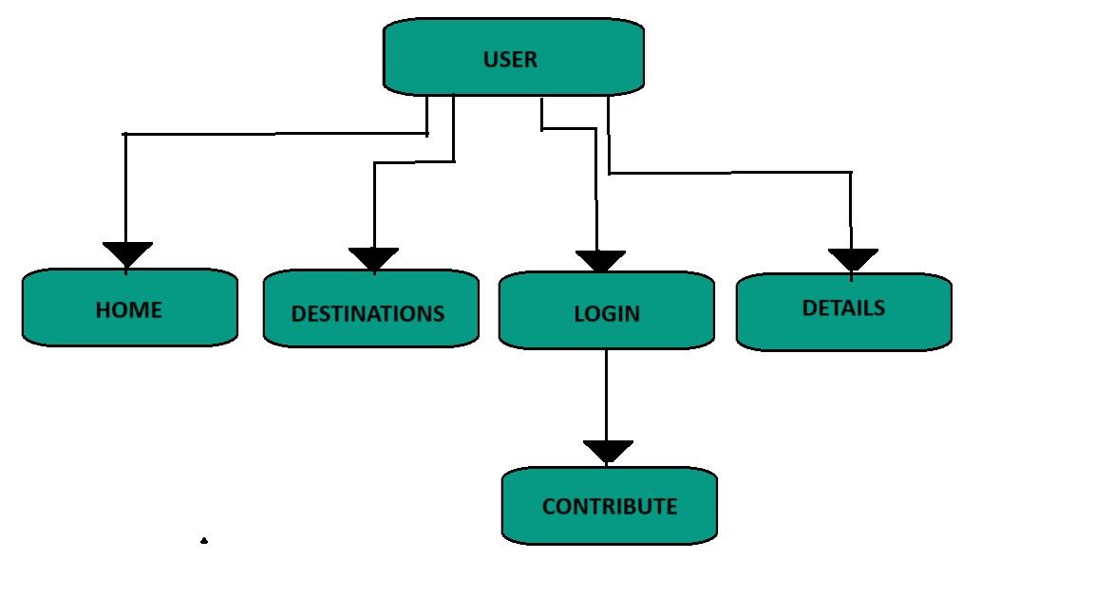

Fig 6.1.1 : A picture of the system architecture

### **6.2 UML Diagram:**

The Unified Modeling Language (UML) is a standard language for specifying, visualizing, constructing, and documenting the artifacts of software systems, as well as for business modeling and other non-software systems. The UML represents a collection of best engineering practices that have proven.

Successful in the modeling of large and complex systems. The UML is a very important part of developing Objects Oriented software and the software development process. The UML uses mostly graphical notations to express the design of software projects. Using the UML helps project teams communicate, and validate the architectural design of the software. System design refers to the process of defining the architecture, components, modules, interfaces, and data for a system to satisfy specified requirements which can be done easily through UML diagrams.

### **Contents of UML:**

In general, a UML diagram consists of the following features:

### **Entities:**

* These may be classes, objects, uses or system behaviors.
* Relationship lines that model the relationship between entities in the system.

### **Generalization:**

A solid line with an arrow that points to a higher abstraction of the present item.

### **Association:**

A solid line that represents that one entity uses another entity as part of its behavior.

### **Dependency:**

A dotted line with an arrowhead that shows one entity depends on the behavior of another entity.

In this project four basic UML diagrams have explained:

1) Use Case Diagram

2) Sequence Diagram

## **1. Use Case Diagram**

A use case diagram in the Unified Modelling Language (UML) is a type of behavioral diagram defined by and created from a Use-case analysis. Its purpose is to present a graphical overview of the functionality provided by a system in terms.

A use case is a methodology used in system analysis to identify, clarify, and organize system requirements. The use case is made up of a set of possible sequences of interactions between systems and users in a particular environment and related to a particular goal. It consists of a group of elements (for example, classes and interfaces) that can be used together in a way that will have an effect larger than the sum of the separate elements combined. The use case should contain all system activities that have significance to the users. A use case can be thought of as a collection of possible scenarios related to a particular goal, indeed, the use case and goal are sometimes considered to be synonymous.

The main purpose of a use case diagram is to show what system functions are performed for which actor. Roles of the actors in the system can be depicted.

##### **Parts of Use Cases:**

A use case describes a sequence of actions that provide something of measurable value to an actor and is drawn as a horizontal ellipse.

**Actors:**

An actor is a person, organization, or external system that plays a role in one or more interactions with the system.

**Include:**

In one form of interaction, a given use case may include another. "Include is a Directed Relationship between two use cases, implying that the behaviour of the included use case is inserted into the behaviour of the including use case”.

##### **Steps To Draw Use cases:**

* 1. Identifying Actor
  2. Identifying Use cases
  3. 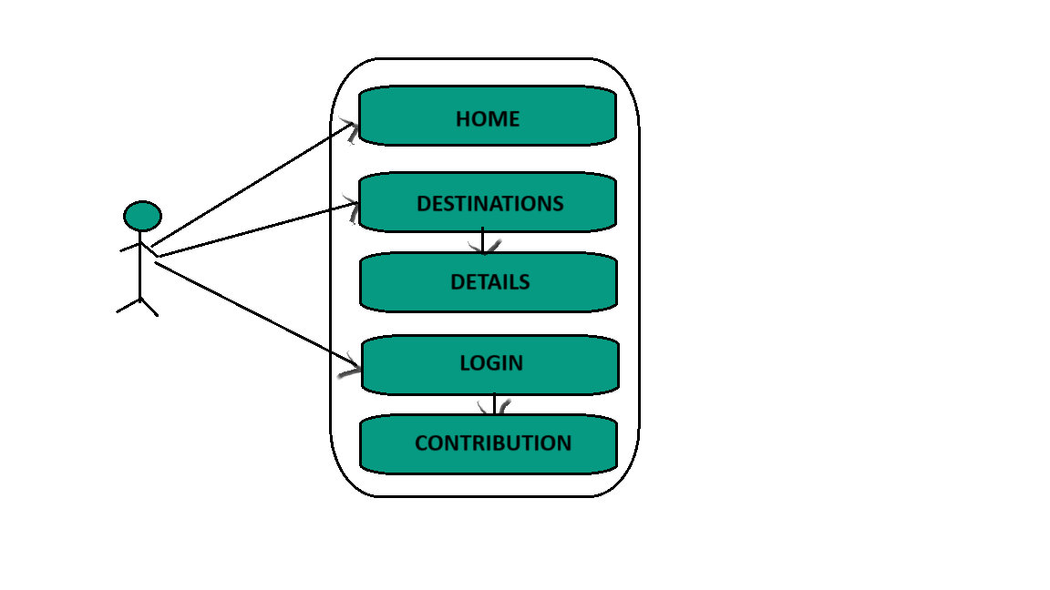Review your use case for completeness

Fig 6.2.1.1 : A picture of the usecase diagram

## **2. Sequence Diagram:**

A sequence diagram in Unified Modelling Language (UML) is a kind of interaction diagram that shows how processes operate with one another and in what order. It is a construct of a Message Sequence Chart. A Sequence diagram depicts the sequence of actions that occur in a system. The invocation of methods in each object, and the order in which the invocation occurs is captured in a Sequence diagram. This makes the Sequence diagram a very useful tool to easily represent the dynamic behaviour of a system.

##### **Elements of sequence diagram:**

The sequence diagram is an element that is used primarily to showcase the interaction that occurs between multiple objects. This interaction will be shown over certain period of time. Because of this, the first symbol that is used is one that symbolizes the object.

**Lifeline:**

A lifeline will generally be generated, and it is a dashed line that sits vertically, and the top will be in the form of a rectangle. This rectangle is used to indicate both the instance and the class. If the lifeline must be used to denote an object, it will be underlined.

**Messages:**

To showcase an interaction, messages will be used. These messages will come in the form of horizontal arrows, and the messages should be written on top of the arrows. If the arrow has a full head, and it’s solid, it will be called a synchronous call. If the solid arrow has a stick head, it will be an asynchronous call. Stick heads with dash arrows are used to represent return messages.

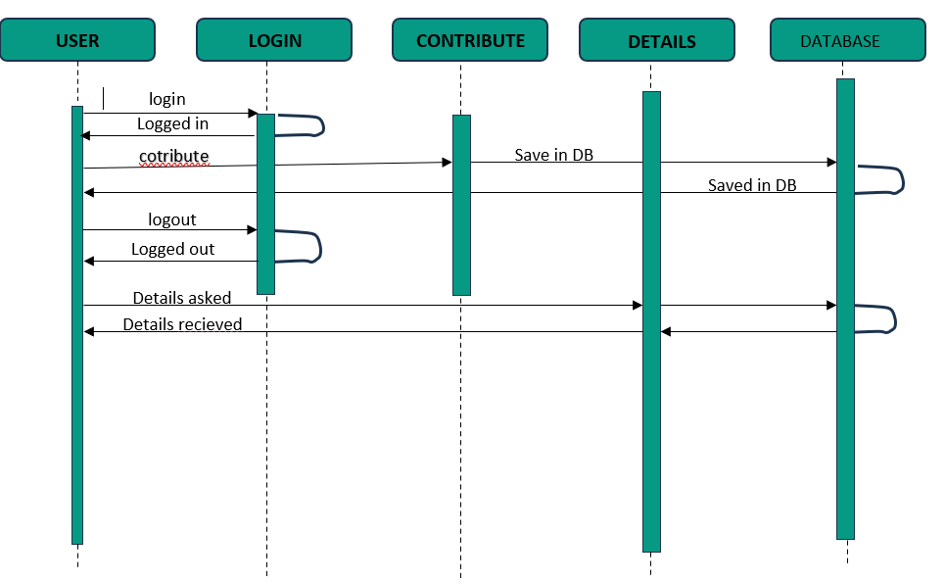

# Fig 6.2.2.1: A picture of the sequence diagram

# **7. SYSTEM IMPLEMENTATION**

# **7.1 Modules:**

**Home Page:**

Memfull is inspired from this situation “when we travel to the new places we will capture many movements and in our mobile phones so the memory our mobile will be filled so, from memory full we created the title ‘Memfull’ “

Navigation Menu: Explore seamlessly through our website with our intuitive navigation menu, providing easy access to various sections.

Search Bar: Helps user to quickly search the places.

Feedback: Which enables the user to give suggestions to the us to improve in the future.

Contact us: Helps user to connect to us through the social media pages.

**Destinations Page:**

Popular destinations: The must visit places in India which are our recommendations

Seach: Enables user to search using the place, nearby place and the category.

Speciality: Describe a little about the speciality of the place.

High quality images: Previews the place beauty.

**Details Page:**

History of the location: Provides the detailed history of the location.

Beauty of the location: Provides the detailed speciality of the location.

Route from a famous place: Provides the detailed route to reach the location from the famous place in India.

Google map location: Provides the user link to the google maps with the destinations marked in it so, it easy to the user to travel to the destination.

Comment box: Facilitates the user to share the experience with the traveller’s community and read the comments of the other travellers in the community.

User images: Facilitates the traveller to share his experience in the form of images to travellers in the community and also see the experiences of the other travellers.

**Contribution Page:**

Login: User should login before the contributing in to the database.

Contribution page: User can seamlessly fill the form and enter the details of the place.

**7.2 User:**

On the Memfull platform, users can effortlessly discover a wealth of travel experiences. Upon arrival at the homepage, visitors are greeted with an introduction to the platform's features and benefits. From there, they can navigate to the About Us page to learn about the passionate team behind Memfull and the mission that fuels our commitment to enhancing travel adventures

For users keen to uncover hidden gems and must-visit spots, the Destinations page is a treasure trove. Here, users can search for locations based on their current vicinity or specific interests, finding curated suggestions that cater to various tastes. Each suggested location is presented with a brief description and captivating images, inviting users to delve deeper.

# Clicking on any location directs users to the Place Details page, where they can access comprehensive information about the spot, including user reviews, travel tips, and detailed descriptions. This ensures that travelers are well-informed and excited about their visits.

# Memfull also fosters a vibrant community of explorers. Users who log in can contribute to the platform by adding new places they discover, enriching the database for future adventurers. This feature not only enhances the platform's content but also encourages a sense of community and shared exploration.

# Additionally, the Contact Us page provides an open channel for users to connect with the Memfull team for support or inquiries. Through intuitive design and carefully curated content, Memfull offers a seamless and enriching experience that caters to the diverse needs of travel enthusiasts, making every journey memorable and hassle-free.

# **8. SAMPLE SOURCE CODE**

**Home page:**

<?php

 session_start();

//  $_SESSION['redirect']=$_SERVER['HTTP_REFERER'];

 ?>

<!DOCTYPE html >

<html lang="en">

<head>

  <meta charset="UTF-8">

  <meta name="viewport" content="width=device-width, initial-scale=1.0">

  <title>home page</title>

  <link rel="stylesheet" href="https://cdnjs.cloudflare.com/ajax/libs/font-awesome/6.5.1/css/all.min.css" integrity="sha512-DTOQO9RWCH3ppGqcWaEA1BIZOC6xxalwEsw9c2QQeAIftl+Vegovlnee1c9QX4TctnWMn13TZye+giMm8e2LwA==" crossorigin="anonymous" referrerpolicy="no-referrer">

  <link rel="stylesheet" href="home.css">

  <link rel="stylesheet" href="nav.css">

  <link rel="preconnect" href="https://fonts.googleapis.com">

  <link rel="preconnect" href="https://fonts.gstatic.com" crossorigin>

  <script src="https://cdnjs.cloudflare.com/ajax/libs/jquery/3.7.1/jquery.min.js" integrity="sha512-v2CJ7UaYy4JwqLDIrZUI/4hqeoQieOmAZNXBeQyjo21dadnwR+8ZaIJVT8EE2iyI61OV8e6M8PP2/4hpQINQ/g==" crossorigin="anonymous" referrerpolicy="no-referrer"></script>

  <link href="https://fonts.googleapis.com/css2?family=Comforter+Brush&family=Kanit&display=swap" rel="stylesheet">

  <link rel="shortcut icon" href="logo.jpeg" type="image/x-icon">

  <script>

    $(document).ready(function(){

        $(".search-icon").click(function(){

          console.log("pressed");

            var what=document.querySelector(".search").value;

            window.location.replace('destinations.php?data='+what);

            console.log(what)

            document.querySelector(".popular").innerHTML="Popular destination near "+what;

            $(".locations").load("destination_search.php",{

              search:what

            });

        });

    });

</script>

</head>

<body>

  <!-- <=======================================================NAVIGATION BAR=================================================> -->

  <nav>

    <input type="checkbox" id="check">

    <label for="check" class="checkbtn">

      <i class="fas fa-bars"></i>

    </label>

    <label class="logo font">Memfull</label>

    <ul>

      <li><input type="search" placeholder="Search" class="search"><img src="search.svg" width="10px" height="10px"

          class="search-icon"></li>

      <li><a href="home.html">Home</a></li>

      <li><a href="destinations.php">Destinations</a></li>

      <!-- <li><a href="#">Services</a></li> -->

      <li class="scroll_about"><a onclick="scrollToAbout()"  style="cursor: pointer;">About us</a></li>

      <?php

             if(isset($_SESSION['username'])){

              ?>

            <li><a href="logout.php">Logout</a></li>

            <?php

             }

             else{

                 ?>

                 <li><a href="login.html">Login</a></li>

                <?php

             }

             ?>

    </ul>

  </nav>

  <!-- <=======================================================NAVIGATION BAR=================================================> -->

  <section></section>

  <main>

    <!-- <=======================================================SCROLLING IMAGES=================================================> -->

    <div style="width:100%;position: relative;margin: 1px;overflow-y: hidden;">

      <img src="backbutton.png" alt="" width="70px" height="70px" class="bckbtn">

      <div class="scroll">

        <div> <video src="incrideble india cropped.mp4" class="scroll_items" autoplay controls muted loop style="object-fit: fill;"></video></div>

        <div style="height: 485px;"><img src="image1.webp" class="scroll_items">

          <div class="on_image font">

            <p class="heading_font" style="font-size: 130px; color: whitesmoke;margin: 0px;"> explore the unknow</p>

            <p style="color:whitesmoke;margin: 0px;font-size:30px;position:absolute;left: 284px;bottom:-2px"

              class="font">Discover the world beyond</p>

          </div>

        </div>

        <div style="height: 480px;"><img src="traveller_image2.jpg" class="scroll_items"></div>

        <div><img src="scroll-4.jpg" class="scroll_items"></div>

        <div><img src="scroll-3.jpg" class="scroll_items"></div>

        <div><img src="scroll-2.jpeg" class="scroll_items"></div>

        <div><img src="scroll-1.jpeg" class="scroll_items"></div>

      </div>

      <img src="frontbutton.png" alt="" width="70px" height="70px" class="fntbtn">

    </div>

    <!-- <=======================================================SCROLLING IMAGES=================================================> -->

    <!-- <=======================================================GALLERY IMAGES=================================================> -->

    <div style="margin-top: 70px;">

      <center>

        <p style="font-size: 60px;margin-bottom: 0px;margin-top: 10px;" class="heading_font">Treasure of India</p>

        <p style="font-size: 60px;margin-bottom: 0px;margin-top: 10px;" class="heading_font">Discover it</p>

        <div class="gallery">

          <div class="gallery_image1"><img src="tajmahal.jpg" style="width: 100%; height:100%;object-fit: cover;">

            <div class="gallery_content1">

              <p class="heading_font" style="color:yellow;font-size: 70px;font-weight: 500;">Taj Mahal</p>

            </div>

          </div>

          <div class="gallery_image2"><img src="jogfalls.jpeg"

              style="object-fit: cover;width: 100%;height: 100%;object-position:0% 24%;">

            <div class="gallery_content1">

              <P class="heading_font" style="color:yellow;font-size: 70px;font-weight: 500;">Jog falls</P>

            </div>

          </div>

          <div style="width:30%;height: 30%;" class="gallery_image3"><img src="srinagar.jpg"

              style="object-fit: cover;width: 100%;height: 100%;">

            <div class="gallery_content1">

              <P class="heading_font" style="color:yellow;font-size: 70px;font-weight: 500;">Srinagar</P>

            </div>

          </div>

          <div style="width:30%;height: 30%;" class="gallery_image4"><img src="mysore.jpg"

              style="object-fit: cover;width: 100%;height: 100%;">

            <div class="gallery_content1">

              <P class="heading_font" style="color:yellow;font-size: 70px;font-weight: 500;">Mysore Palace</P>

            </div>

          </div>

          <div style="width:30%;height: 30%;" class="gallery_image5"><img src="kasi.jpg"

              style="object-fit: cover;width: 100%;height: 100%;">

            <div class="gallery_content1" style="bottom: -30px;">

              <P class="heading_font" style="color:yellow;font-size: 70px;font-weight: 500;">Kasi</P>

            </div>

          </div>

        </div>

      </center>

    </div>

    <!-- <=======================================================iMAGES GALLERY=================================================> -->

    <!-- <=======================================================ABOUT US =================================================> -->

    <div class="tohere"></div>

    <div class="about" style="margin-bottom: 50px;">

      <div class="typing">

        <p class="heading_font" style="font-size: 60px;margin: 0px; width: 200px;color:var(--heading);;">About us</p>

      </div>

      <div class="image"><img src="aboutbanner.png" alt="" srcset=""

          style="width:100%;height: 100%;object-fit:contain;">

        </div>

        <div class="about_content">

          <p class="heading_font" style="margin: 0px;font-size: 42px;">Explore the India with us</p>

          <p style="width: 450px;" class="font">At Memfull, we believe that travel isn’t just about reaching </p>

          <!-- <img src="compass.svg" alt="" srcset="" width="30px" height="30px"> -->

          <p class="heading_font" style="font-size: 40px;margin: 0px;color:var(--heading)">Tour guide</p>

          <p class="font" style="width: 450px;">We believe that the best way to understand a place is</p>

        <p class="heading_font" style="font-size: 40px;margin: 0px;color:var(--heading)">Accurate</p>

        <p class="font" style="width: 450px;">We don’t take shortcuts. Our team of</p>

        </div>

      </div>

      <!-- <=======================================================ABOUT US =================================================> -->

    </main>

    <!-- <=======================================================FOOTER =================================================> -->

    <footer style="position: relative;">

      <label class="logo font" style="color:white;position:absolute;top:160px">Memfull</label>

       <div class="contact_us">

        <h1 style="color:white;font-size: 45px;" class="heading_font">Contact US</h1>

        <p>Feel free to contact us<br>and reach  us!! </p>

        <p>Instagram</p>

        <p>Facebook</p>

        <p>Twiter</p>

       </div>

       <div class="feedback" >

        <h1 style="color: white;font-size: 45px;" class="heading_font">Feedback</h1>

        <input type="text" name="" id="" placeholder="Name"><br><br>

        <input type="email" name="" id="" placeholder="Email"><br><br>

        <textarea type="text" name="" id="" style="width: 300px;height: 100px;resize: none;" class="font" placeholder="your feedback is very important to us please give us your genuine feedback "></textarea><br>

        <input type="submit" value="Submit" style="width: 306px;">

       </div>

    </footer>

    <!-- <=======================================================FOOTER=================================================> -->

  <script>

    b = document.querySelector(".bckbtn")

    f = document.querySelector(".fntbtn")

    let c=0;

    s = document.querySelector('.scroll')

    b.addEventListener("click", () => {

      s.scrollLeft -= 1000;

      // console.log("clicked back button");

    });

    f.addEventListener("click", () => {

      s.scrollLeft += 1000;

      c++;

      if(c==7){

        s.scrollLeft -= 6000;

        c=0;

      }

      // console.log("clicked front button");

    });

    function scrollToAbout(){

      document.querySelector(".tohere").scrollIntoView();

  }

  </script>

</body>

</html>

**Destinations:**

<?php

session_start();

$_SESSION['redirect']=$_SERVER['HTTP_REFERER'];

?>

<!DOCTYPE html>

<html lang="en">

<head>

    <!-- <script src="https://cdnjs.cloudflare.com/ajax/libs/jquery/3.7.1/jquery.min.js" integrity="sha512-v2CJ7UaYy4JwqLDIrZUI/4hqeoQieOmAZNXBeQyjo21dadnwR+8ZaIJVT8EE2iyI61OV8e6M8PP2/4hpQINQ/g==" crossorigin="anonymous" referrerpolicy="no-referrer"></script> -->

    <!-- <script src="https://code.jquery.com/jquery-3.7.1.js" integrity="sha256-eKhayi8LEQwp4NKxN+CfCh+3qOVUtJn3QNZ0TciWLP4=" crossorigin="anonymous"></script> -->

    <script src="https://ajax.googleapis.com/ajax/libs/jquery/3.7.1/jquery.min.js"></script>

    <meta charset="UTF-8">

    <meta name="viewport" content="width=device-width, initial-scale=1.0">

    <title>Destinations</title>

    <link rel="stylesheet" href="home.css">

    <link rel="stylesheet" href="nav.css">

    <link rel="preconnect" href="https://fonts.googleapis.com">

    <link rel="preconnect" href="https://fonts.gstatic.com" crossorigin>

    <link href="https://fonts.googleapis.com/css2?family=Comforter+Brush&family=Kanit&display=swap" rel="stylesheet">

    <!-- <=======================================================SHADOW INTO LIGHT=================================================> -->

    <link rel="preconnect" href="https://fonts.googleapis.com">

<link rel="preconnect" href="https://fonts.gstatic.com" crossorigin>

<link href="https://fonts.googleapis.com/css2?family=Merienda:wght@300..900&family=Shadows+Into+Light&display=swap" rel="stylesheet">

    <link rel="stylesheet" href="destinations.css">

    <script src="destinations.js"></script>

    <link rel="shortcut icon" href="logo.jpeg" type="image/x-icon">

    <script>

        $(document).ready(function(){

            $(".search_button").click(function(){

                var what=document.querySelector(".input_search").value;

                if(what==null||!isAlphaNumeric(what)||what==""){

                  $("#warning").css({"display":"block",});

                  return;

                }

                else{

                    $("#warning").css({"display":"none",});

                }

                // document.querySelector(".popular").innerHTML="Popular destination near "+what;

                $(".locations").load("destination_search.php",{

                          search:what

                });

            });

        });

        function isAlphaNumeric(str) {

  var code, i, len;

  for (i = 0, len = str.length; i < len; i++) {

    code = str.charCodeAt(i);

    if (!(code > 47 && code < 58) && // numeric (0-9)

        !(code > 64 && code < 91) && // upper alpha (A-Z)

        !(code > 96 && code < 123)&&

        !(code==32)) { // lower alpha (a-z)

      return false;

    }

  }

  return true;

};

    </script>

</head>

<body>

    <!-- <=======================================================NAVIGATION BAR=================================================> -->

    <nav>

        <input type="checkbox" id="check">

        <label for="check" class="checkbtn">

            <i class="fas fa-bars"></i>

        </label>

        <label class="logo font">Memfull</label>

        <ul>

            <li><input type="search" placeholder="Search" class="search"><img src="search.svg" width="10px" height="10px" class="search-icon"></li>

            <li><a href="home.php">Home</a></li>

            <li><a href="destinations.php">Destinations</a></li>

            <li><a href="contribution.php">Contribute</a></li>

            <!-- <li><a href="#">Services</a></li> -->

            <!-- <li class="scroll_about"><a onclick="scrollToAbout()">About us</a></li> -->

             <?php

             if(isset($_SESSION['username'])){

              ?>

            <li><a href="logout.php">Logout</a></li>

            <?php

             }

             else{

                 ?>

                 <li><a href="login.html">Login</a></li>

                <?php

             }

             ?>

        </ul>

    </nav>

    <!-- <=======================================================NAVIGATION BAR=================================================> -->

    <!-- <=======================================================SEARCH BOX=================================================> -->

    <center>

        <div class="destination">

            <div class="dest_search">

                <input type="search" name="input" id="" class="input_search" placeholder="Where your soul want to wander?">

                <button class="search_button" name="search">SEARCH</button>

            </div>

            <p style="display: none;position:absolute;top:85px;left:70px;color:red" class="font" id="warning">search can't be empty</p>

            <div style="position: absolute; top: 100px; width: 100%;">

                <p class="heading_font popular" style="font-size: 60px;margin-bottom: 20px;">Popular Destinations</p>

            </div>

        </div>

    </center>

    <div class="locations"></div>

    <!-- <=======================================================SEARCH BOX=================================================>  -->

    <!-- <=======================================================FOOTER =================================================> -->

    <footer style="position: relative;">

        <!-- <script>createcard()</script> -->

        <label class="logo font" style="color:white;position:absolute;top:160px">Memfull</label>

        <div class="contact_us">

            <h1 style="color:white;font-size: 45px;" class="heading_font">Contact US</h1>

            <p>Feel free to contact us<br>and reach us!! </p>

            <p>Instagram</p>

            <p>Facebook</p>

            <p>Twiter</p>

        </div>

        <div class="feedback">

            <h1 style="color: white;font-size: 45px;" class="heading_font">Feedback</h1>

            <input type="text" name="" id="" placeholder="Name"><br><br>

            <input type="email" name="" id="" placeholder="Email"><br><br>

            <textarea type="text" name="" id="" style="width: 300px;height: 100px;resize:none" class="font"

            placeholder="your feedback is very important to us please give us your genuine feedback "></textarea><br>

            <input type="button" value="Submit" style="width: 306px;">

        </div>

    </footer>

    <!-- <=======================================================FOOTER=================================================> -->

<?php

    $con=mysqli_connect("localhost","root","","memfull");

    $sql="select * from popular;";

    $res=mysqli_query($con,$sql);

    while($row=mysqli_fetch_assoc($res)){

        $heading=$row["name"];

        $matter=$row["speciality"];

        $filename=$row["filename"];

        ?>

<script>

var h = "<?php echo"$heading"?>";

var m = "<?php echo"$matter"?>";

var pic="<?php echo"$filename"?>";

</script>

<?php

echo "<script type='text/javascript'>createcard()</script>";

}

?>

<?php

if(isset($_GET['data'])){?>

    <script>

    $(document).ready(function(){

            var what="<?php echo $_GET['data'];?>";

            $(".locations").load("destination_search.php",{

                      search:what

            });

    });

</script>

<?php } ?>

</body>

</html>

**Details page:**

<?php

  $place = $_GET['p'];

  $con = mysqli_connect('localhost', 'root', '', 'memfull');

  $row = mysqli_query($con, "select * from places where name='$place'");

  $res = mysqli_fetch_assoc($row);

  $heading = $res['filename'];

  $lat = $res['latitude'];

  $lon = $res['longitude'];

  session_start();

  $_SESSION['redirect']=$_SERVER['HTTP_REFERER'];

  ?>

  <!DOCTYPE html>

  <html lang="en">

  <head>

    <meta charset="UTF-8">

    <meta name="viewport" content="width=device-width, initial-scale=1.0">

    <title><?php echo $place ?></title>

    <link rel="shortcut icon" href="logo.jpeg" type="image/x-icon">

    <link rel="stylesheet" href="https://cdnjs.cloudflare.com/ajax/libs/font-awesome/6.5.1/css/all.min.css"

      integrity="sha512-DTOQO9RWCH3ppGqcWaEA1BIZOC6xxalwEsw9c2QQeAIftl+Vegovlnee1c9QX4TctnWMn13TZye+giMm8e2LwA=="

      crossorigin="anonymous" referrerpolicy="no-referrer">

    <link rel="stylesheet" href="details.css">

    <link rel="stylesheet" href="nav.css">

    <link rel="stylesheet" href="home.css">

    <link rel="preconnect" href="https://fonts.googleapis.com">

    <link rel="preconnect" href="https://fonts.gstatic.com" crossorigin>

    <link href="https://fonts.googleapis.com/css2?family=Kanit&display=swap" rel="stylesheet">

    <link rel="preconnect" href="https://fonts.googleapis.com">

    <link rel="preconnect" href="https://fonts.gstatic.com" crossorigin>

    <script src="https://cdnjs.cloudflare.com/ajax/libs/jquery/3.7.1/jquery.min.js"

      integrity="sha512-v2CJ7UaYy4JwqLDIrZUI/4hqeoQieOmAZNXBeQyjo21dadnwR+8ZaIJVT8EE2iyI61OV8e6M8PP2/4hpQINQ/g=="

      crossorigin="anonymous" referrerpolicy="no-referrer"></script>

    <link href="https://fonts.googleapis.com/css2?family=Comforter+Brush&family=Kanit&display=swap" rel="stylesheet">

    <link rel="shortcut icon" href="logo.jpeg" type="image/x-icon">

    </script>

    <script src="https://cdnjs.cloudflare.com/ajax/libs/jquery/3.7.1/jquery.min.js" integrity="sha512-v2CJ7UaYy4JwqLDIrZUI/4hqeoQieOmAZNXBeQyjo21dadnwR+8ZaIJVT8EE2iyI61OV8e6M8PP2/4hpQINQ/g==" crossorigin="anonymous" referrerpolicy="no-referrer"></script>

    <script>

      $(document).ready(function() {

        $(".search-icon").click(function() {

          console.log("pressed");

          var what = document.querySelector(".search").value;

          window.location.replace('destinations.php?data=' + what);

          console.log(what)

          document.querySelector(".popular").innerHTML = "Popular destination near " + what;

          $(".locations").load("destination_search.php", {

            search: what

          });

        });

      });

    </script>

  </head>

  <body>

    <!-- <=======================================================NAVIGATION BAR=================================================> -->

    <nav>

      <input type="checkbox" id="check">

      <label for="check" class="checkbtn">

        <i class="fas fa-bars"></i>

      </label>

      <label class="logo font">Memfull</label>

      <ul>

        <li><input type="search" placeholder="Search" class="search"><img src="search.svg" width="10px" height="10px"

            class="search-icon"></li>

        <li><a href="home.php" target="_blank">Home</a></li>

        <li><a href="destinations.php" target="_blank">Destinations</a></li>

        <li><a href="contribution.php" target="_blank">Contribute</a></li>

        <!-- <li class="scroll_about"><a onclick="scrollToAbout()">About us</a></li> -->

        <?php

             if(isset($_SESSION['username'])){

              ?>

            <li><a href="logout.php" target="_blank">Logout</a></li>

            <?php

             }

             else{

                 ?>

                 <li><a href="login.html" target="_blank">Login</a></li>

                <?php

             }

             ?>

      </ul>

    </nav>

    <!-- <=======================================================NAVIGATION BAR=================================================> -->

    <!-- <=======================================================place image=================================================> -->

    <center>

      <div class="details-images">

        <img src="images/<?php echo $heading ?>" alt="" srcset="" style="">

        <h1 class="details-title heading_font"><?php echo $place ?></h1>

      </div>

    </center>

    <!-- <script>alert("<?php echo $lat . "+" . $lon ?>");</script> -->

    <!-- <=======================================================place image=================================================> -->

    <!-- <=======================================================SPECIATLITY=================================================> -->

    <div class="content">

      <p class="heading_font" style="text-transform: capitalize;font-size: 40px;">the Beauty Of the <?php echo $place ?></p>

      <p class="font"><?php echo $res['speciality'] ?></p>

    </div>

    <div class="content">

      <p class="heading_font" style="text-transform: capitalize;font-size: 40px;">the history of the <?php echo $place ?></p>

      <p class="font"><?php echo $res['history'] ?></p>

    </div>

    <div class="content">

      <p class="heading_font" style="text-transform: capitalize;font-size: 40px;">route form famous places to <?php echo $place ?></p>

      <p class="font"><?php echo $res['way'] ?></p>

    </div>

    <!-- <=======================================================SPECIATLITY=================================================> -->

    <center>

      <iframe src="https://www.google.com/maps?q=<?php echo $res['latitude'] . ',' . $res['longitude'] ?>&hl=ez;z=14&output=embed" width="600" height="450" style="border:0;" allowfullscreen="" loading="lazy" referrerpolicy="no-referrer-when-downgrade"></iframe>

    </center>

    <div style="width: 100%;display:flex;justify-content:space-between;height:fit-content">

      <!-- <=======================================================comment box =================================================> -->

      <div class="commentbox">

        <div class="write">

          <p class="font"><?php if(isset($_SESSION['username']))

          echo $_SESSION['username'];

          else

          echo "username";

          ?></p>

          <form method="post" id="comment">

            <textarea name="comment" id="" class="data" placeholder="leave a experince of you here so other can have glipse of the happiness of the place"></textarea>

            <input type="text" name="username" value="<?php echo $_SESSION['username']; ?>" hidden>

            <input type="text" name="place" value="<?php echo $place ?>" hidden>

            <button type="submit" class="comment_button">comment</button>

          </form>

        </div>

        <p style="color: red; display:none;" class="font" id="comment_warning">please login before posting the comment</p>

        <div class="comments">

          <?php

          $comment = mysqli_query($con, "select * from comments where place='$place';");

          while ($crow = mysqli_fetch_assoc($comment)) {

            ?>

            <div class="user">

              <p><?php echo $crow['username'] ?></p>

              <p><?php echo $crow['comment'] ?></p>

            </div>

            <?php

          }

          ?>

        </div>

      </div>

      <!-- <=======================================================comment box =================================================> -->

      <!-- <=======================================================user images=================================================> -->

      <div class="userimages">

        <div class="images">

          <?php

           $ires=mysqli_query($con,"select * from image_user where place='$place';");

           while($irow=mysqli_fetch_assoc($ires)){

             ?>

           <img src="<?php echo "user_images/".$irow['filename']; ?>" alt="" srcset="" class="userimage">

           <?php

           }

           ?>

        </div>

        <form  method="post" enctype="multipart/form-data" id="userimages_form">

          <input type="file" name="userimage" id="file" >

          <input type="text" name="place" id="" value="<?php echo $place; ?>" hidden>

          <button type="submit" id="userimage_button">submit</button>

        </form>

        <p style="color: red; display:none;" class="font" id="image_warning">please login before uploading the image</p>

      </div>

      <!-- <=======================================================user images=================================================> -->

    </div>

    <!-- <=======================================================FOOTER =================================================> -->

    <footer style="position: relative;">

      <label class="logo font" style="color:white;position:absolute;top:160px">Memfull</label>

      <div class="contact_us">

        <h1 style="color:white;font-size: 45px;" class="heading_font">Contact US</h1>

        <p>Feel free to contact us<br>and reach us!! </p>

        <p>Instagram</p>

        <p>Facebook</p>

        <p>Twiter</p>

      </div>

      <div class="feedback">

        <h1 style="color: white;font-size: 45px;" class="heading_font">Feedback</h1>

        <input type="text" name="" id="" placeholder="Name"><br><br>

        <input type="email" name="" id="" placeholder="Email"><br><br>

        <textarea type="text" name="" id="" style="width: 300px;height: 100px;resize:none" class="font" placeholder="your feedback is very important to us please give us your genuine feedback "></textarea><br>

        <input type="submit" value="Submit" style="width: 306px;">

      </div>

    </footer>

    <!-- <=======================================================FOOTER=================================================> -->

    <script>

      <?php

      if(isset($_SESSION['username'])){

      ?>

      $(document).ready(function() {

        $(".comment_button").click(function(event) {

            event.preventDefault();

            document.getElementById("comment_warning").style.display = "none";

            $.ajax({

              type: 'POST',

              url: 'insert_comment.php',

              data:$("#comment").serialize(),

            })

            $(".data").val("");

          })

        })

        $(document).ready(function(){

          $("#userimage_button").click(function(event){

            event.preventDefault();

            var form=new FormData(document.getElementById('userimages_form'))

            $.ajax({

              type:'POST',

              url:'insert_images.php',

              data: form,

              processData:false,

              contentType:false,

              })

              $("#file").val("")

          })

        })

        <?php

      }

      else{

      ?>

      $(document).ready(function(){

        $(".comment_button").click(function(event){

          event.preventDefault();

          document.getElementById('comment_warning').style.display='block';

        })

      })

      $(document).ready(function(){

        $("#userimage_button").click(function(event){

          event.preventDefault();

          document.getElementById('image_warning').style.display='block';

        })

      })

      <?php

      }

      ?>

    </script>

  </body>

  </html>

**9. User interface designs**

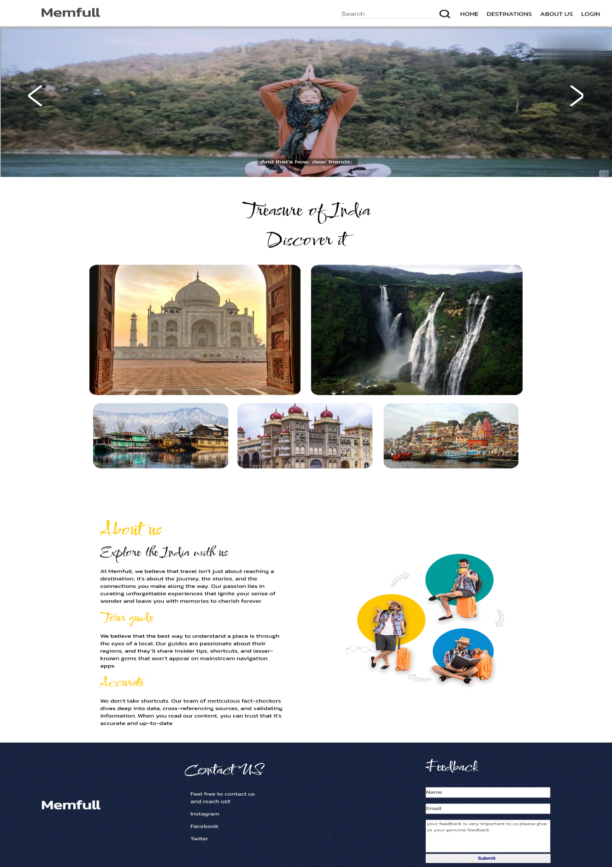**9.1 Home page:**

Fig 9.1.1: A picture of the home page

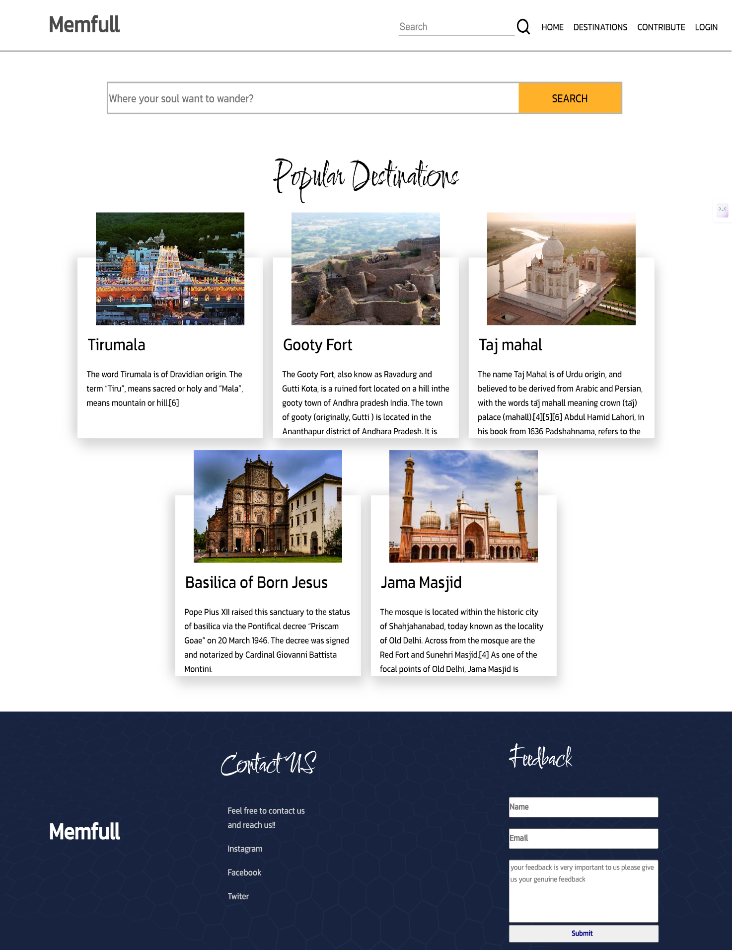**9.2 Destinations page:**

Fig 9.2.1:A picture of Destinations page

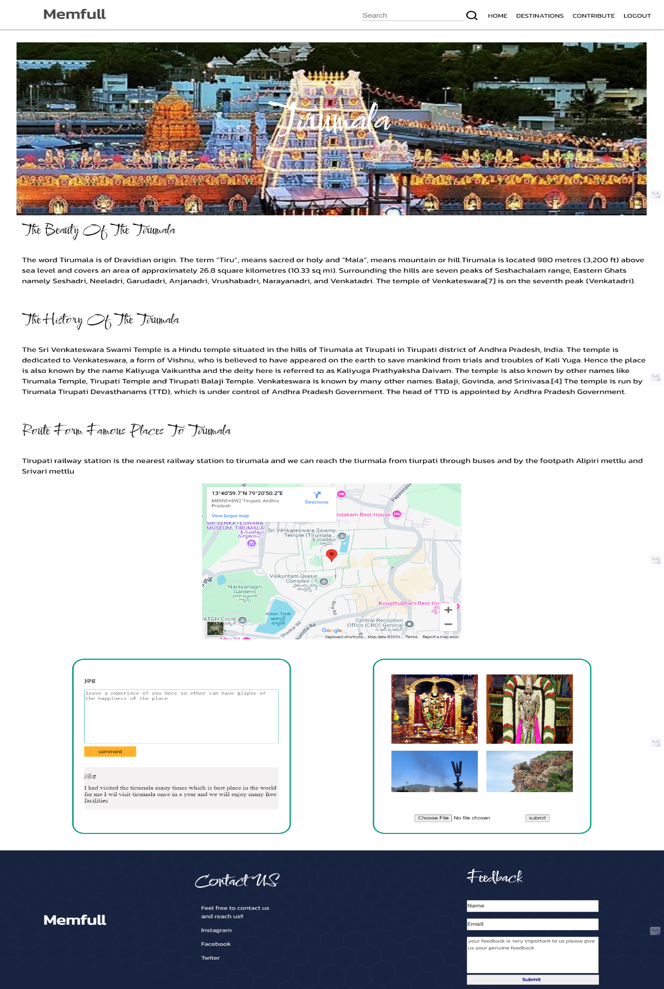**9.3 Details page:**

Fig 9.3.1: Details page

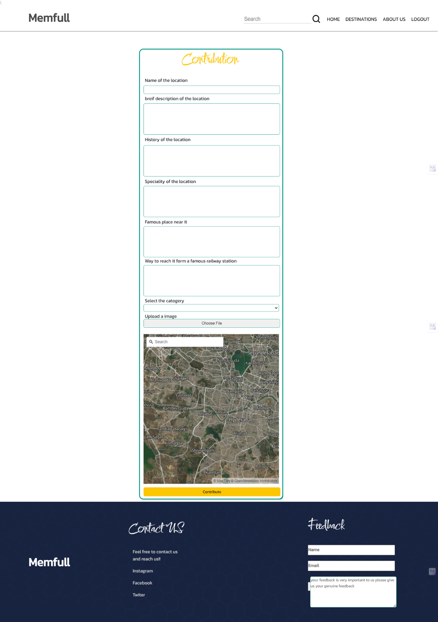**9.4 Contribution Page:**

Fig 9.4.1: A picture of the contribution page

**9.5 Login Page:**

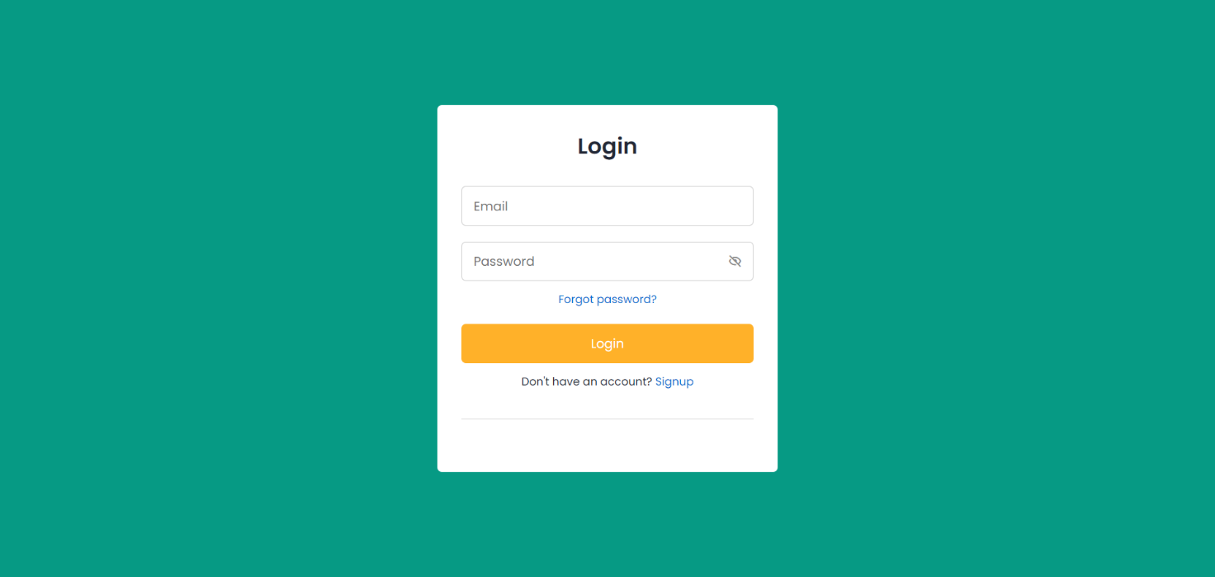Fig 9.5.1: A picture of the login page

**10.6 Signup page:**

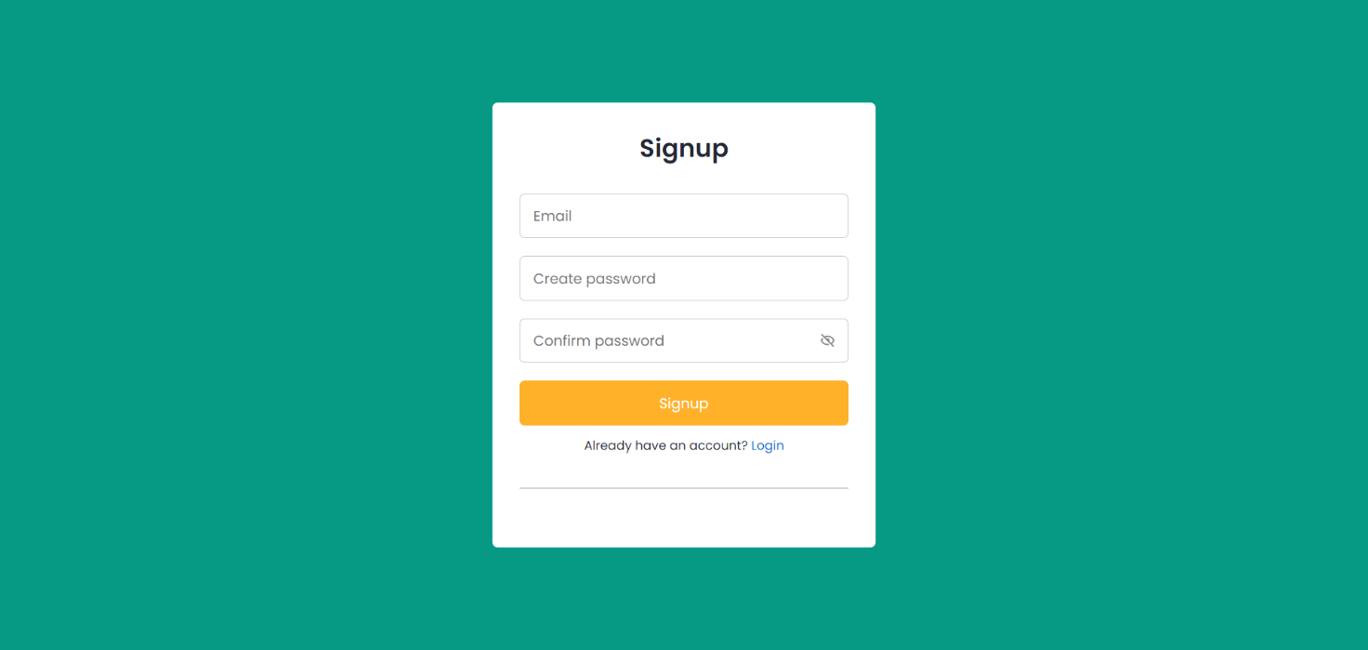

Fig 9.6.1: A picture of the signup page

# **10. TESTING**

When developing an online tourism website using HTML, CSS, JavaScript, and PHP, it is essential to conduct various types of testing to ensure its functionality, reliability, and security. Here are some types of testing that can be performed on the system:

**Unit Testing:**

This type of testing focuses on testing individual components or modules of the system. In the context of an online touring system, it involves testing functions written in JavaScript and PHP to ensure they perform as expected. Unit testing can be performed using frameworks such as PHP Unit for PHP and Jest or Mocha for JavaScript.

**Integration Testing:**

Integration testing involves testing the interaction between different components of the system. In the case of an online tourism website, it includes testing the integration between the front-end (HTML, CSS, and JavaScript) and the back-end (PHP) to ensure seamless communication and data.

**System Testing:**

This type of testing verifies whether the system functions correctly according to the specified requirements. It involves testing different features and functionalities of the Memfull website, such as displaying the details of the place, searching of the place, displaying the images. Test cases should cover both normal and exceptional scenarios to ensure all functionalities work as expected.

**Usability Testing:**

Usability testing focuses on evaluating the user-friendliness and intuitiveness of the system's user interface (HTML, CSS). It involves testing how easily users can navigate the system, complete tasks, and understand the Instructions. Feedback from real users can be gathered to assess the system's usability and identify areas for improvement.

**10.1 TESTCASES**

**10.1.1 Testcase - 1**

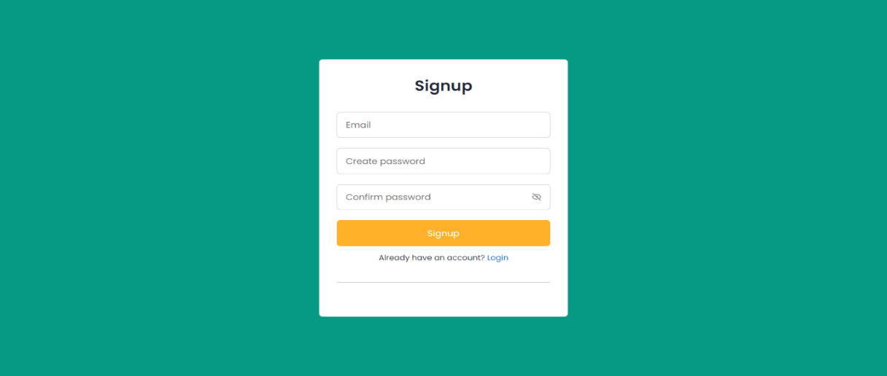 The purpose of the signup page is to register the user into the website database so he can login to the website in the future.

Fig 10.1.1.1: A picture of the signup page

**Expected output:** After the data entry the Email id is validated and the password is validated it checks whether the password contains 8 characters or not and if the password and the confirm password are same then it will display a message that registered successfully and redirect you to the home page if the doesn’t match then it will display a message that password and the confirm password must be same.

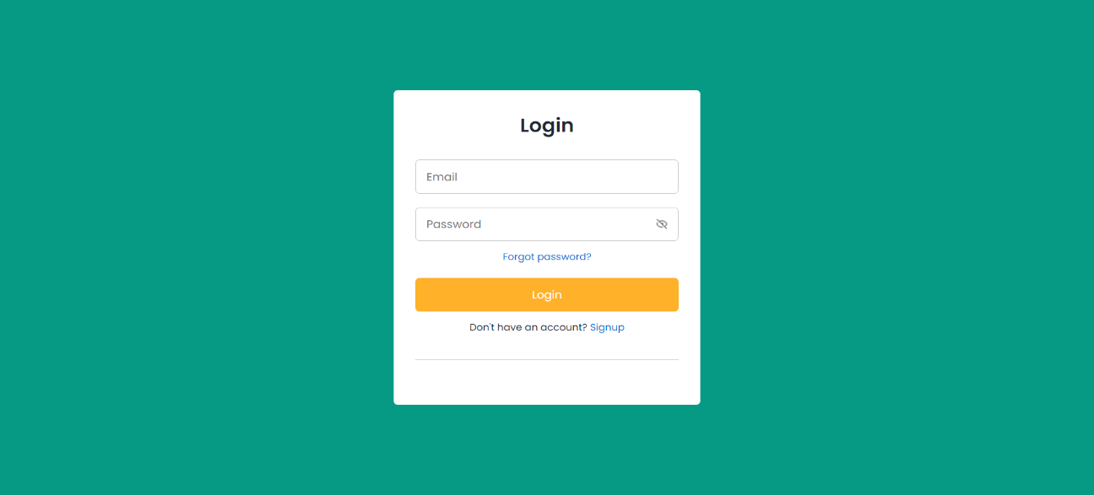**Output:**

fig 10.1.1.2: A picture of the login page

**10.1.2 Testcase - 2**

The purpose of this is to verify the user credentials and give access to the user to contribute, comment, upload the images into the website.



Fig 10.1.2.1: A picture of the login page

**Expected output:** After entering the data is verified and the user credentials are present in the database then user will be redirected to the home page. If the user credentials aren’t present then the “you must register first” message will be display

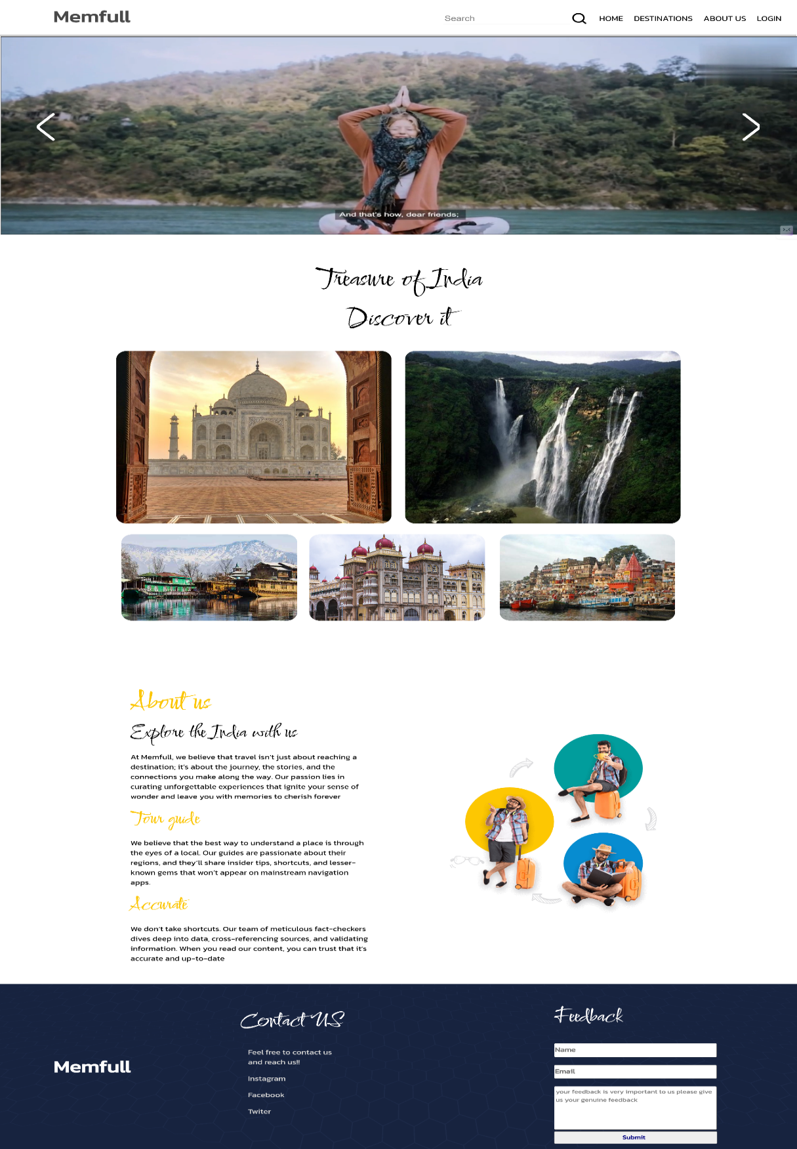**Output:**

Fig 10.1.2.3: A picture of the home page

**10.1.3 Testcase - 3**

The purpose of this feature is to search the database to get the details of the desired location.

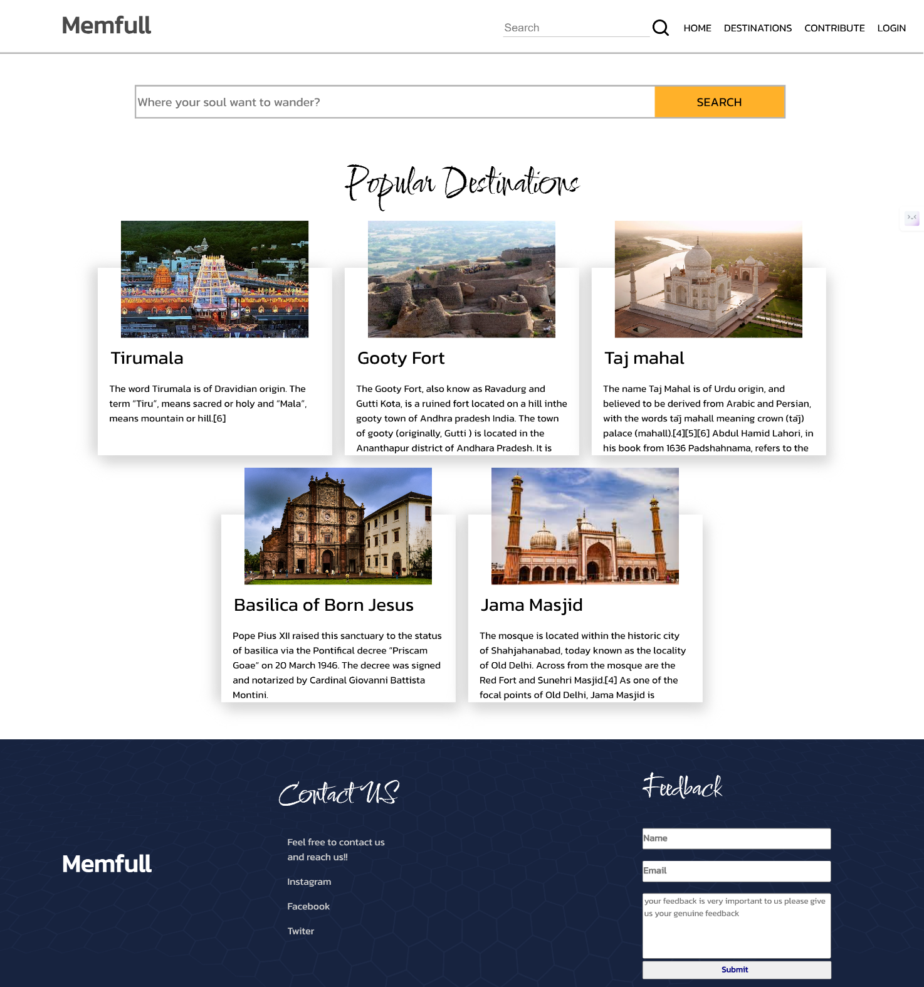

Fig 10.1.3.1: A picture of the destinations page

**Expected output:** After entering the keyword (place or category) it the search box. The PHP searches the database and the show all the nearby places of the place will be displayed in the page and these are clickable results if you click on it. It will show the details of the clicked place. If the place is not found it will display the 404 error.

**Output:**

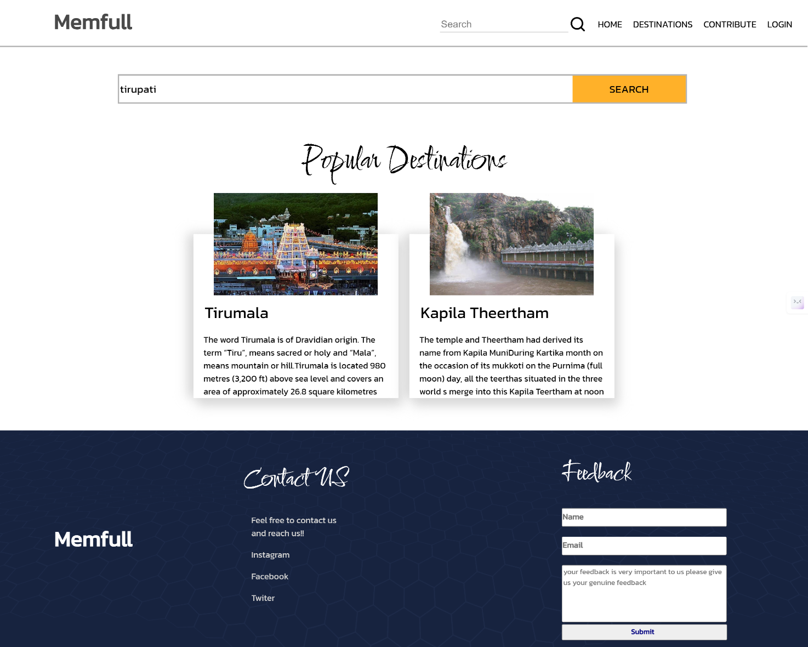

Fig 10.1.3.1: A picture of the destinations page

**11. CONCLUSION**

In conclusion, Memfull simplifies travel planning by offering a user-friendly platform to discover must-visit locations. From the Home Page to the Destinations and Contact Us pages, we provide reliable travel solutions and direct communication channels.

Looking ahead, we aim to enhance user experience with AI/ML integration and real-time weather updates, expanding our database to cater to diverse tastes. Memfull embodies convenience, transparency, and community engagement, making it a trusted companion for unforgettable adventures.

**12. FUTURE SCOPE**

The Memfull team is committed to continuous improvement and innovation. We are dedicated to enhancing our platform to better serve our users. By actively seeking feedback, staying abreast of the latest technological advancements, and regularly updating our features, we ensure that Memfull remains a top-tier travel planning resource. Our mission is to provide an unparalleled user experience, helping travelers discover and cherish memorable experiences effortlessly.

**Incorporating Advanced Technologies:** Memfull aims to leverage cutting-edge technologies such as Artificial Intelligence (AI) and Machine Learning (ML) to enhance the efficiency and accuracy of destination recommendations. By analyzing user preferences, browsing behavior, and feedback, our platform will offer personalized suggestions tailored to each user's needs and preferences.

**Integration of real time wheather:** At Memfull, we are excited to announce the upcoming integration of real-time weather updates on our platform. This feature will provide users with current weather conditions and forecasts for their desired destinations, ensuring they are well-prepared for their trips. Whether planning a day at the beach or a hike in the mountains, travellers can make informed decisions with up-to-date weather information, enhancing the overall travel experience. Stay tuned as we continue to enhance Memfull with features designed to make your adventures even more seamless and enjoyable

**Collaborating with the tour planners:** The future, we aim to enhance the Memfull experience by collaborating with various tour planners. These partnerships will allow us to offer exclusive discounts and special deals to our users, making their travel adventures more affordable and enjoyable. By integrating these benefits, Memfull will not only help users discover incredible destinations but also provide cost-effective travel solutions. Stay tuned as we continue to expand our network and bring you more value-packed journeys.

**Enhance the user experience:**  Memfull is committed to continually enhancing the user experience by leveraging cutting-edge technology and user feedback. We are dedicated to making travel planning seamless, intuitive, and enjoyable. Our team actively works on integrating new features, improving navigation, and ensuring that every interaction on our platform is smooth and satisfying. With each update, we aim to exceed user expectations and deliver a travel planning experience that is second to none.

**13.REFERENCES**

1. API Documentation: <https://docs.maptiler.com/sdk-js/api/>
2. jQuery reference: <https://youtu.be/ejN-oAw9vC0?si=EK0mYgRvkRe4eaxw>
3. Website reference: <https://www.incredibleindia.gov.in/en>
4. W3schools.com

5.Used the google and black box ai.